Business Intelligence & Analytics for Online Bookstore

Introduction-
Online Book Store Data Analytics is a data-driven project aimed at analyzing customer purchases, book inventory, and sales trends for an online bookstore. With the increasing growth of e-commerce in the publishing industry, understanding customer preferences, high-selling book categories, and revenue patterns is essential for improving business performance and customer satisfaction.
This project uses a dataset that includes customer details, book information, and order transactions to extract meaningful insights for strategic decision-making.
Objectives-
The main objectives of this project are:
- To analyze sales performance based on books, quantity sold, and order trends.
- To understand customer demographics and purchasing behavior.
- To study the popularity of authors and book genres.
- To identify high-revenue and low-revenue categories to optimize inventory.
- To provide business recommendations for revenue growth and operational improvement.
Problem Statement-
The online book store is facing challenges in understanding its sales trends, customer purchasing behavior, most demanded books and genres, inventory stock levels, and revenue performance. Due to a lack of analytical insights, the business is unable to identify top-selling and low-performing books, high-value customers, and seasonal demand patterns. This affects decision-making in marketing, pricing, and inventory planning.
The project aims to analyze sales, customer, and book-related data using EXCEL ,SQL AND POWER BI to generate meaningful insights that will support better business strategy, improve stock management, enhance customer experience, and increase overall profitability.
Importance and Relevance-
Data analytics plays a crucial role in helping online bookstores understand market demand, customer behavior, and sales performance. By analyzing order, customer, and book data, businesses can identify best-selling genres and authors, forecast trends, and make informed decisions about pricing and stock management. It helps improve customer satisfaction by offering personalized recommendations and ensuring the availability of popular books.
This project is highly relevant because it supports effective business planning, increases revenue opportunities, reduces losses from unsold inventory, and strengthens competitive advantage in the growing online book market.
Tools and Technologies Used-
- Microsoft Excel – Used for data cleaning, organizing, and performing preliminary analysis with formulas, pivot tables, and charts.
- SQL (Structured Query Language) – Used to query and extract meaningful insights from the database, such as sales trends, customer behavior, and inventory data.
- Power BI – Used to create interactive dashboards and visualizations for tracking sales performance, customer demographics, and book popularity.

Data analysis using SQL-
We performed structured analysis in PostgreSQL to answer key business
questions:

Retrieve top 5 books in the "Fiction" genre-
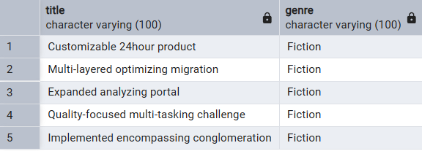
Find books published after the year 1950-

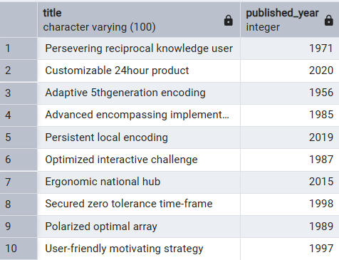

List all customers from the Canada-
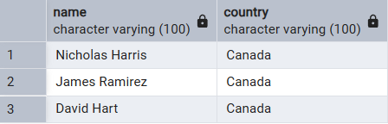

Show orders placed in November 2023-
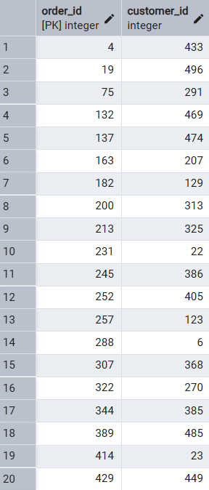
Retrieve the total stock of books available-

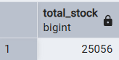

Show all top 10 customers who ordered more than 1 quantity of a book
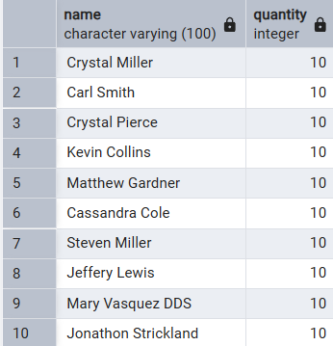
Retrieve all orders where the total amount exceeds $450-
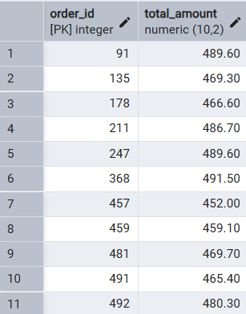

List all genres available in the Books table-
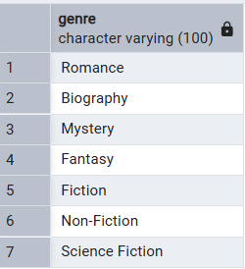
Find the book with the lowest stock-
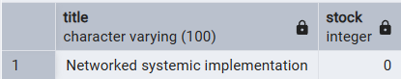
Calculate the total revenue generated from all orders-
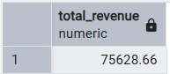
Retrieve the total number of books sold for each genre-
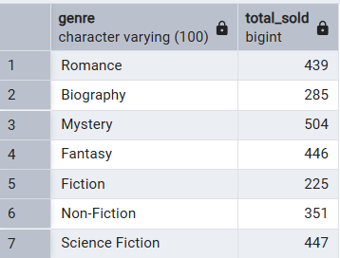
Find the average price of books in the "Fantasy" genre-
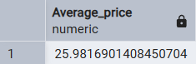
List customers who have placed at least 2 orders-
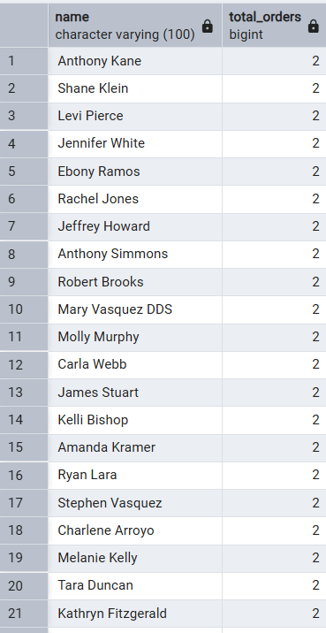

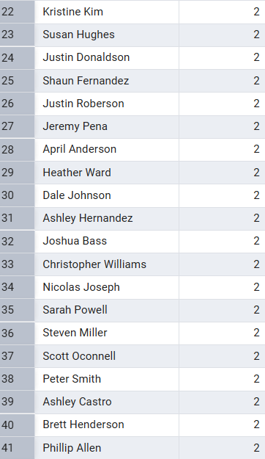

Find the most frequently ordered book-
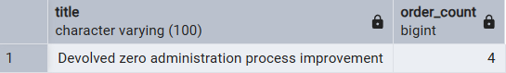

Show the top 3 most expensive books of 'Fantasy' Genre-
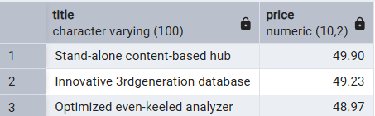
Retrieve the total quantity of books sold by each author (TOP 5) -
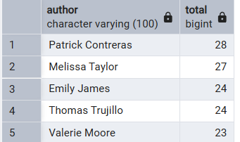
Find the customer who spent the most on orders (TOP 5) –
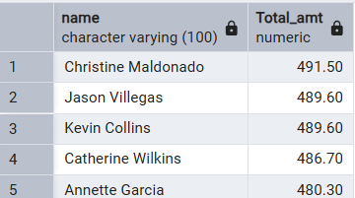

Power BI Dashboard Description
The Power BI dashboard created for the Online Book Store Data Analytics project provides a clear and interactive visualization of sales performance, customer activity, and book popularity. It includes essential KPIs such as Total Sales, Total Quantity Sold, Total Customers, Total Sales, and Number of Authors, giving an overall summary of business results.
The dashboard contains multiple slicers that allow users to filter the data based on Year, Published Year, Country, Top-Selling Books, and Top 5 Cities. These interactive filters help stakeholders analyze data from different perspectives effectively.
Key visual components of the dashboard include:
- Total Sales by Year to analyze annual performance trends.
- Maximum and Minimum Price of Books to observe pricing variation.
- Top 5 Authors based on sales performance.
- Top 5 Countries by Sales to understand global sales distribution.
- Top-Selling Books and Top 5 Cities by Sales to identify strong revenue sources and customer preference patterns.
This dashboard assists in identifying high-performing and low-performing books, understanding customer purchasing behavior, and making informed decisions related to marketing, pricing, and inventory planning to improve overall profitability.
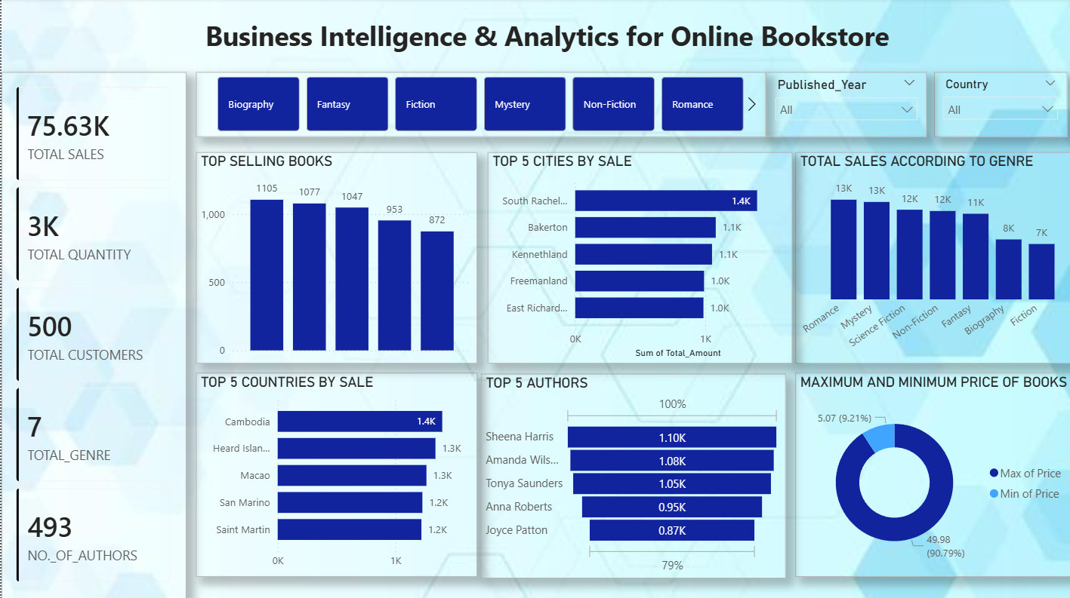

Business Recommendations-
- Focus on Top-Selling Books & Genres-
Increase stock and promotional visibility for best-selling books, authors, and genres to maximize revenue and satisfy demand.
- Strengthen Marketing in High-Revenue Countries & Cities-
Since certain countries and top 5 cities contribute the majority of sales, implement location-based marketing campaigns and improve delivery services in those regions.
- Expand Market Reach in Low-Sales Regions-
Offer free/discounted shipping or referral programs to increase customer acquisition from lower-performing regions.
- Enhance Customer Engagement & Loyalty
Introduce personalized recommendations, membership programs, and email campaigns based on customer purchase history to increase repeat purchases.

